Project Development Phase
Model Performance Test

Date | 08/10/2026
Team ID | SWTID-2026-3272
Project Name | Implement Client Script and UI Policy (Incident)
Maximum Marks | 10 Marks

Model Performance Testing:
Project team shall fill the following information in model performance testing template.
S.No. | Parameter | Values | Screenshot
 | Model Summary | ServiceNow automation setup for Incident management using Client Script and UI Policy on the Incident [incident] table.  UI Policies (no-code form control)  1. Mandatory fields for High urgency: when Urgency is 1 - High, Assignment group and Description become mandatory (Reverse if false = true).  2. Lock closed incidents: when State is Closed, Short description, Category and Caller become read-only.  Client Scripts (client-side logic)  1. onLoad - Incident Form Guidance: shows an info message asking the user to provide complete details.  2. onChange (Urgency) - High Urgency Alert: warns the user to assign the incident immediately when Urgency is 1 - High.  3. onSubmit - Validate Short Description: blocks Save if the short description has fewer than 10 characters.  function onSubmit() {  var s = g_form.getValue(  'short_description');  if (s.length < 10) {  g_form.showFieldMsg(  'short_description',  'Min 10 characters',  'error');  return false;  }  }  Note : If the policy condition or script validation matches, the UI Policy / Client Script is applied on the Incident form; otherwise the form keeps its default behaviour or shows an error message. | 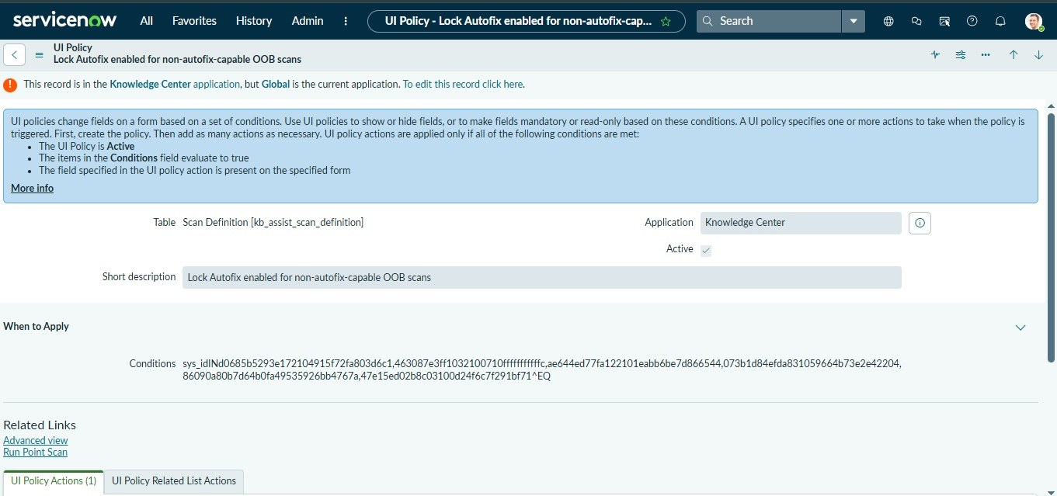  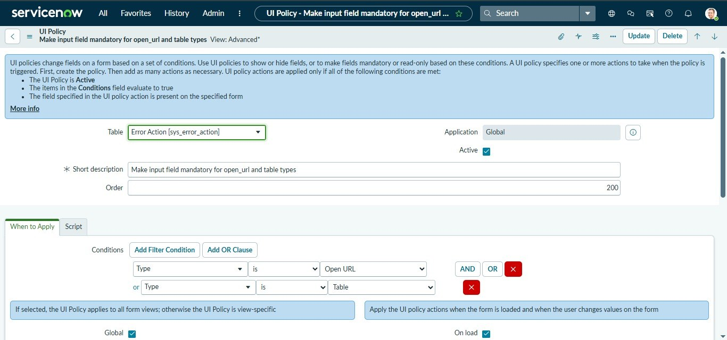  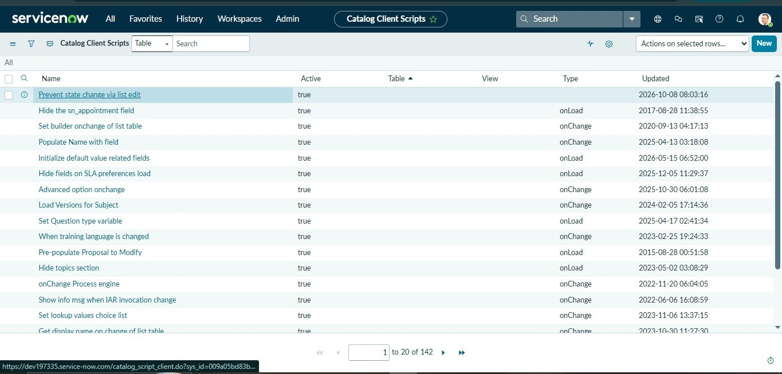
 | Accuracy | Functional Accuracy - 100%  Test cases executed - 6  Test cases passed - 6  Test cases failed - 0  Validation Accuracy - 100% (form behaviour matched the expected result in every case)  Test scenarios  1. Urgency = 1 - High: Assignment group and Description turn mandatory - Pass  2. Urgency changed to 2 or 3: fields return to optional - Pass  3. State = Closed: Short description, Category and Caller read-only - Pass  4. Open a new incident: guidance message displayed (onLoad) - Pass  5. Change Urgency to 1 - High: alert message displayed (onChange) - Pass  6. Save with short description under 10 characters: error shown, save blocked (onSubmit) - Pass | 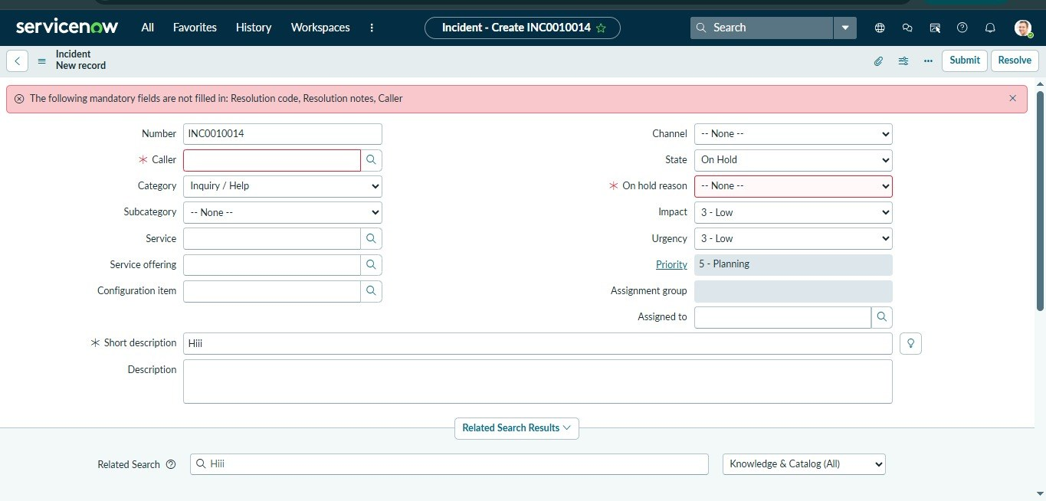  [Insert screenshot: read-only fields on a Closed incident]  [Insert screenshot: info message / alert shown by the onLoad and onChange scripts]  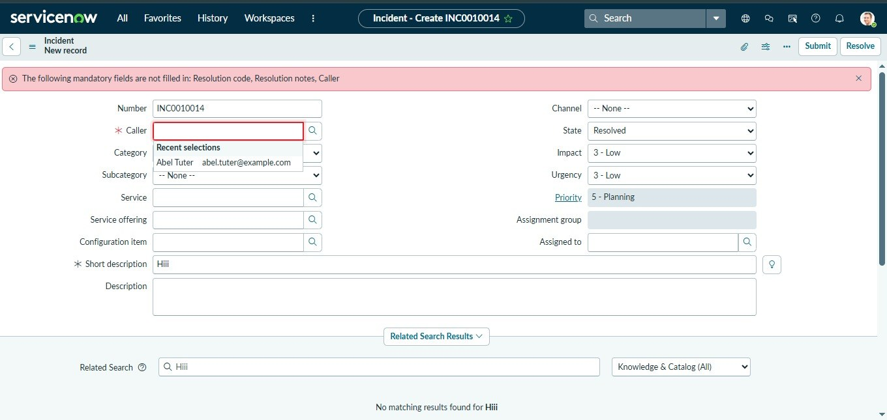
3. | Confidence Score (Only Yolo Projects) | Not applicable - this project is a ServiceNow configuration (Client Script and UI Policy). It does not use a YOLO / object-detection model, so no class detection or confidence score is generated.  Equivalent check - Condition Match  Class Detected - Urgency = 1 - High (UI Policy and Client Script condition) and State = Closed  Confidence Score - 100%: the policy or script runs only when its condition matches; otherwise the default form behaviour continues. | Not applicable (non-YOLO project).  